**DAILY ONLINE ACTIVITIES SUMMARY**

|  |  |  |  |  |  |  |  |  |
| --- | --- | --- | --- | --- | --- | --- | --- | --- |
| **Date:** | **12/06/2020** | | | | | **Name:** | **AKASH S** | |
| **Sem & Sec** | **4TH&A** | | | | | **USN:** | **4AL18CS004** | |
| **Online Test Summary** | | | | | | | | |
| **Subject** | | **ADALITHA KANNADA** | | | | | | |
| **Max. Marks** | | **25** | | **Score** | | | **21** | |
| **Certification Course Summary** | | | | | | | | |
| **Course** | **Front end Development-HTML** | | | | | | | |
| **Certificate Provider** | | | **GREAT LEARNING** | | **Duration** | | | **3.5 HOURS** |
| **Coding Challenges** | | | | | | | | |
| **Problem Statement 1:** **Write a Java Program to find total number of subarrays which start and end with the same element.** | | | | | | | | |
| **Status: executed** | | | | | | | | |
| **Uploaded the report in Github** | | | | | **YES** | | | |
| **If yes Repository name** | | | | | <https://github.com/akashacharya786/lockdown-c-coding>  **https://github.com/akashacharya786/lockdown-java-coding** | | | |
| **Uploaded the report in slack** | | | | | **YES** | | | |

Online Test Summary: Adalitha kannada online test was scheduled from 11:30AM to12 pm. The portion for the IA was all 10 chapters. The question were MCQ type There were 25 question each question carries 1 mark respectively duration is 30 minutes .The score I received was 21/25.

Snap Shot:

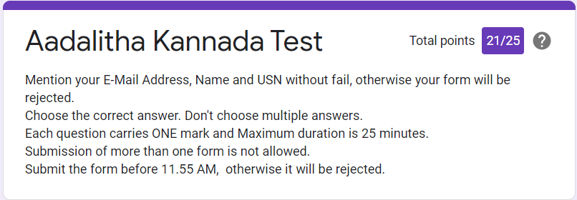

**Online Certification course:**

Name of the course : Front end Development-HTML

Duration: 3.5 hours

Certificate provider: great learning

Today I have successfully completed Front end Development-HTML . I have written a assessment quiz and successfully received the certificate

Snap shot:

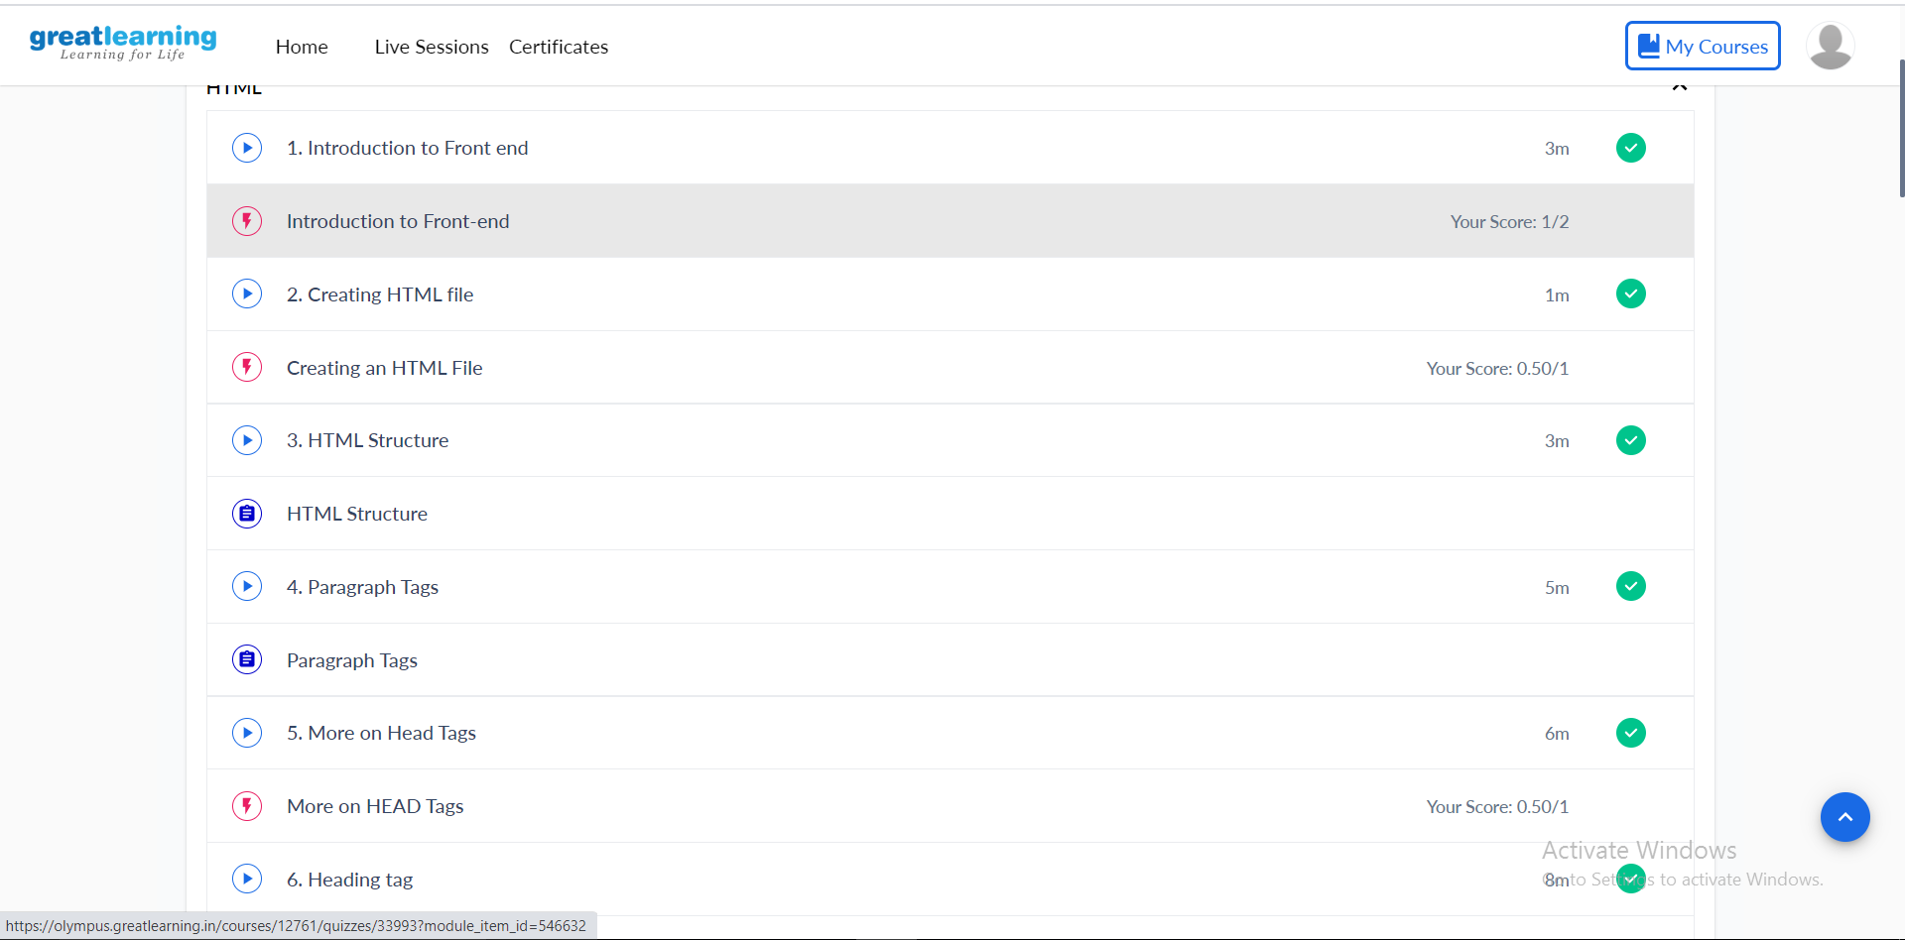

Certificate:

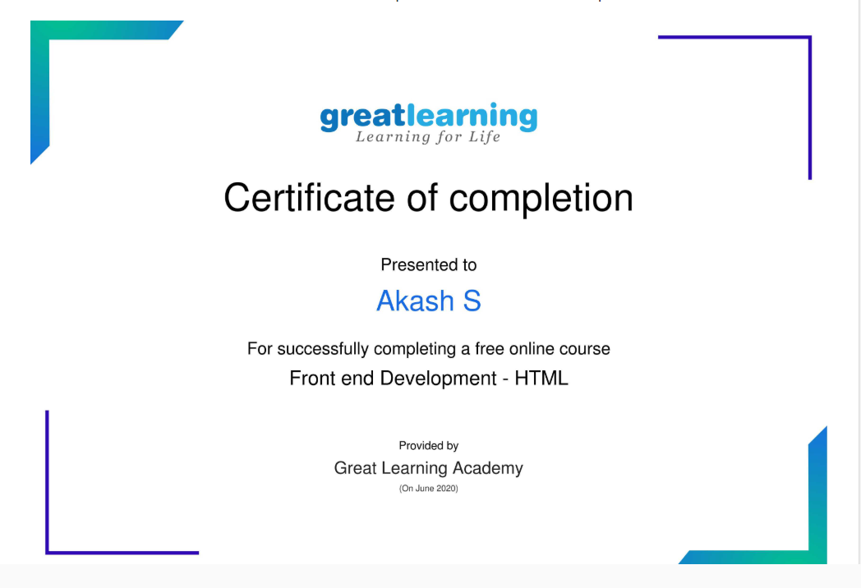

Online Coding summary:

1. **Write a Java Program to find total number of subarrays which start and end with the same element.**

